**Experiment Overview**

We hosted data set for twitter tweets on both Azure and AWS database and created Azure function and AWS lambda APIs to call queries. This allowed us to analyse both Azure and AWS for various types of metrics mention in research method. Figure 5.1 and 5.2 depict an overview of the scenario to access MSSQL database using Node.js runtime in Azure function and AWS Lambda, respectively. Figure 5.3 shows an overview of the Usability Test Design of AWS lambda and Azure function.

### 5.1.1 Azure Overview

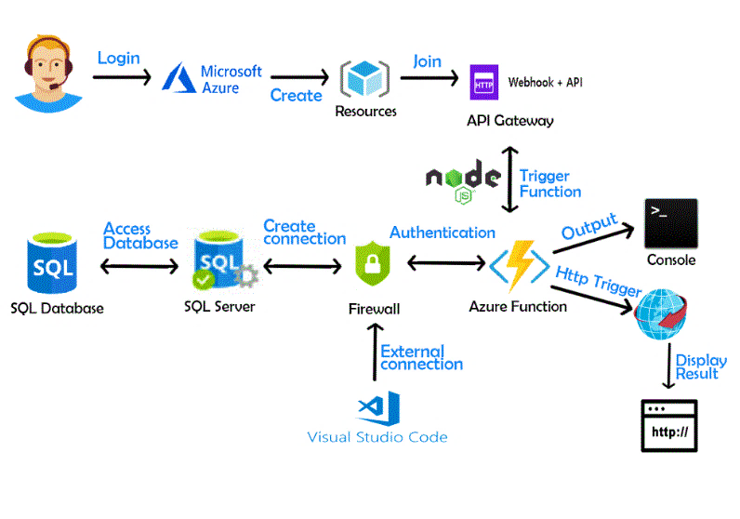

**Figure 5.1**- Scenario to access MSSQL database using Node.js runtime in Azure function.

### AWS Overview

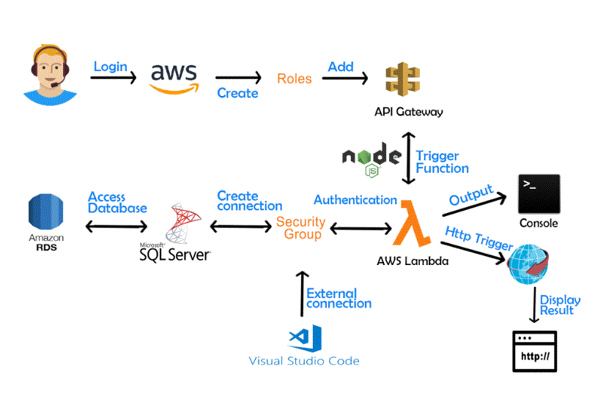

**Figure 5.2**- Access MSSQL database using Node.js runtime in AWS Lambda.

### 5.1.3 Usability Test Design

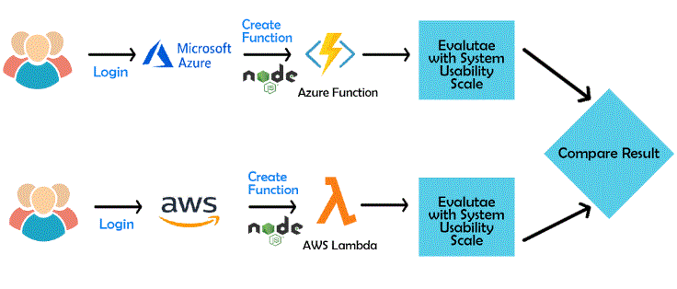

**Figure 5.3**- Usability Test Design of AWS lambda vs Azure function.